Welcome to the Pacific Indemnity Broker Portal

What’s in this guide?
How does it work?
- Brief diagrams of the processes of getting an Auto Quote, Referred Quotes, Send Link to Client, Binding Cover
Who can I contact?
How to Access the Portal
- Activating Your Account
- Setting your password
- Accessing the Portal
- Resetting Your Password
New Business Quotes
- There are over 400 Professional Services listed, of which approx. 250 will auto-rate
- Get instant indications of price
- Edit the Professional Services Covered
- NSW Small Business Insurance Duty Exemption Declaration question
- Broadform Liability Cover
Send a link to your client
- Your client can review the detail in the proposal form and submit their confirmation of answers back to you before you submit it to us
What should I do if I get an Error Message?
- Try to refresh your screen, log out and log - in again in the case that your session has timed out
Renewal Quotes
- Expiring terms based on previously disclosed information are released to the Portal, and can be bound subject to there being no material change to the risk and subject to qualifying criteria
Quote Summary Screen
- A summary of your quote, what you can see and do in this screen
Print/Download Proposal
- Save or print a copy of the proposal answers in a PDF file
Bind Cover
- Immediately receive your Policy Documents and Certificate of Currency
Refer or Message the Underwriter
- For your Renewal Transfer risks, or an account you are trying to win, or any other reason, you can type a message, upload documents and ‘Refer to Underwriter’ to review the automatically produced quote
Referred Quotes
- Receive a response to your Referred quotes within 24 hours (of the next business day)
Search your existing Quotes and Policies
- All quotes and policies linked to your brokerage are visible on the Portal
How does it work?

Auto Quotes – a quote indication is generated. When the final identifying details are entered e.g. other names and address, a formal binding quote can be emailed and can be bound on-line
Proposal Screen  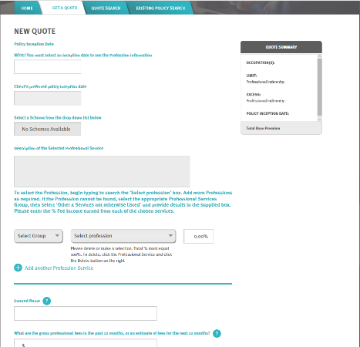  Select:  - Inception Date (today or later)  - Profession(s)  - Limit  - Excess  Enter:  - Insured Name  - Fees  - Income per State %  Answer:  - Addendum questions (if any)  - Overseas Income  - Public Liability cover  Click Next |  | Quote Summary Screen  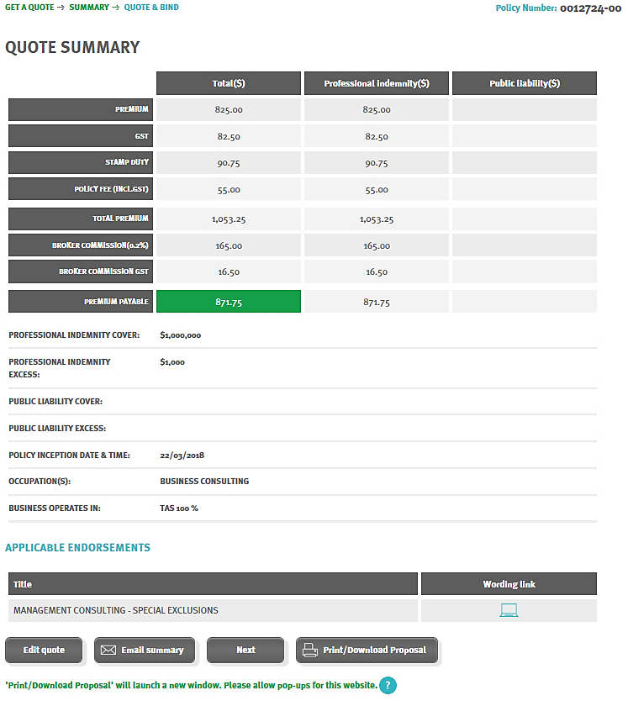  Review:  - Premium  - Limit  - Excess  - Inception Date  - Occupation(s)  - State(s) of risk  - Applicable Endorsements  You can:  - Edit quote  - Email Summary  - Print/Download Proposal  - Proceed to Quote & Bind screen |  | Quote & Bind screen  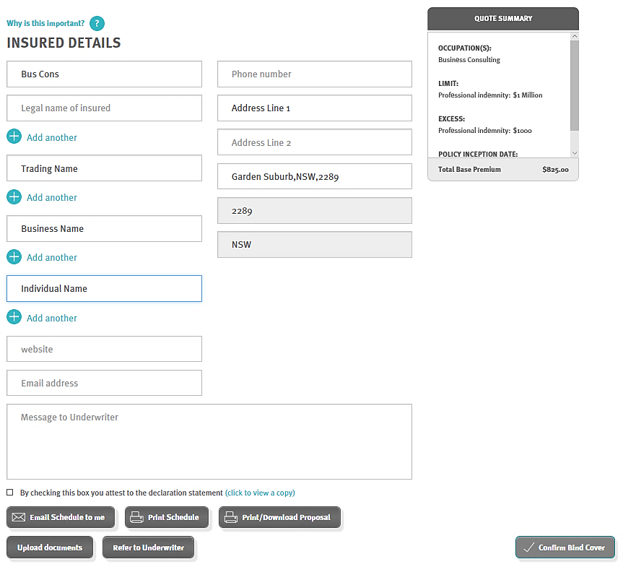  Enter:  - Additional Names (if any)  - Address Details  You can:  - Email Quote Schedule to you  - Print Schedule  - Print/Download Proposal  - Refer to Underwriter  - Bind Cover  To Refer to an Underwriter for review:  - Add a Message to Underwriter  - Upload Documents

Referred Quotes – detail(s) need to be reviewed by an underwriter before a formal response can be provided. If the quote request is accepted, this appears as a Quoted status. You will receive a response within 24 hours on the next business day
Proposal Screen  Select:  - Inception Date (today or later)  - Profession(s)  - Limit  - Excess  Enter:  - Insured Name  - Fees  - Income per State %  Answer:  - Addendum questions (if any)  - Overseas Income  - Public Liability cover  Click Next |  | Referral Screen  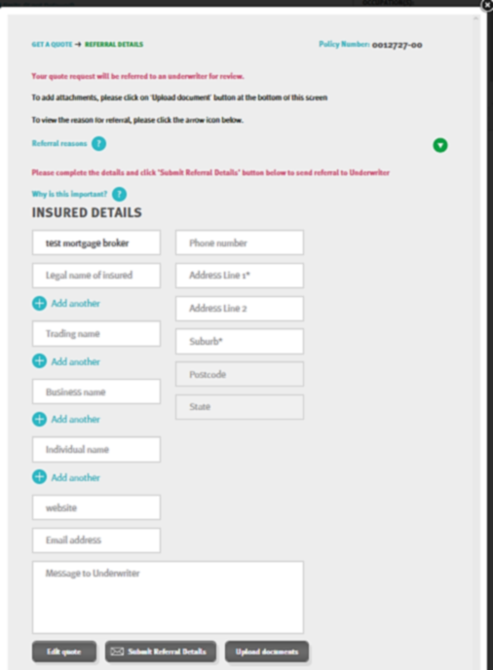  Enter:  - Additional Names (if any)  - Address Details  - s  You can:  - Add a Message to Underwriter  - Upload Document  - Edit quote  Submit Referral Details |  | Within 24 Hours on next business day  Receive response from a Pacific Indemnity Underwriter  - Accepted & Quoted  or  - Request for more information  or  - Declined to quote
Send Link to Client – a link is sent to the email address nominated by you, is valid for 10 days and allows your client to review and/or change details in the proposal screen
Send Link to Client screen  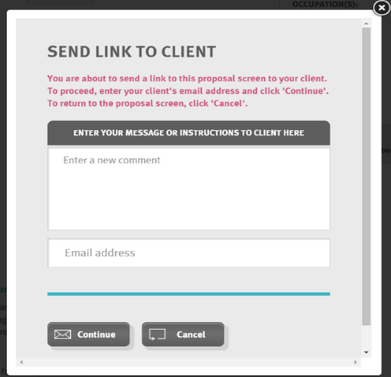  - Enter a message you would like to appear at the top of your client’s proposal form  - Enter your client’s email address  - Click Continue |  | Client completes & returns  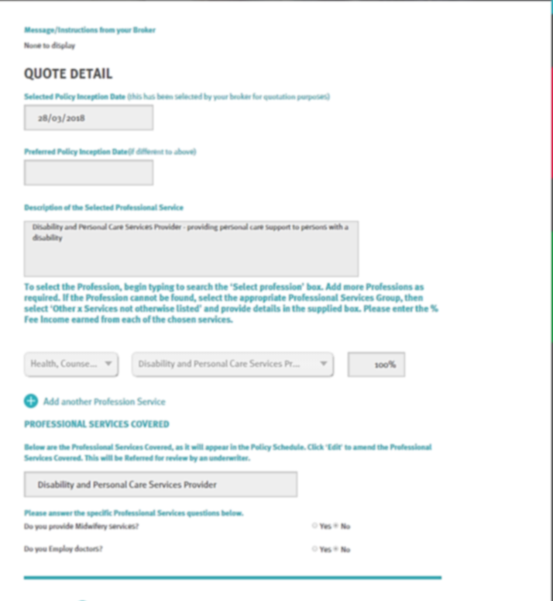  - You will receive an email advising that your client has completed their proposal form  - You can review and amend as required & click Next |  | Submit to receive Auto Quote or Refer to Underwriter  - Follows the processes above, once the proposal is received and submitted by you  - Auto Quotes are available for Binding Cover on-line and immediately receive the policy documents via email

Binding Cover
Review Inception Date & Cover  SUMMARY and QUOTE & BIND links are not active if the inception date is incorrect/invalid i.e. must be equal to or greater than today’s date  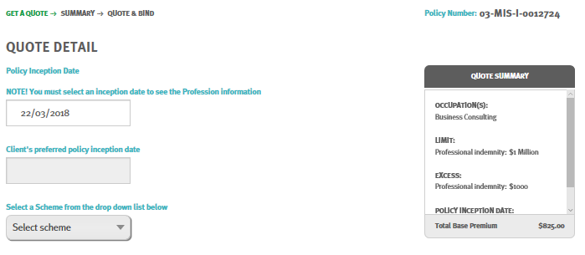  - Update cover options |  | Quote Summary Screen to Quote & Bind screen  Proceed via Quote Summary  and/or  Jump directly to Quote & Bind screen |  | Click the Declaration Statement & Confirm Bind Cover  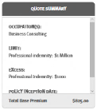  Quote Summary shows the cover being bound  - Click to attest to the Declaration Statement  - Click  - Immediately receive the Policy Documents via email

Who can I contact?
- To get help filling in the proposal – please phone or email your underwriting contact
- If you receive an error - please email admin@pacificindemnity.com.au and cc your underwriting contact with details of the action you were performing and any screen shots would greatly assist with resolving the problem
Our contact details are:
Who | Title | Call | Email
Sharmella Perera | Systems & Administration | 0401 035 687 | sharmella.perera@pacificindemnity.com.au
Steven Duckworth | Business Development | 0431 796 953 | steven.duckworth@pacificindemnity.com.au
Andrea Skan | Senior Underwriter | 0419 237 270 | andrea.skan@pacificindemnity.com.au
Michelle Imlach | Senior Underwriter | 0402 240 098 | michelle.imlach@pacificindemnity.com.au
Robert Beaton | Senior Underwriter | 0401 731 272 | robert.beaton@pacificindemnity.com.au
Simone Oakman | Senior Underwriter | 0431 618 869 | simone.oakman@pacificindemnity.com.au
Jun Acance | Director | 0401 712 017 | jun.acance@pacificindemnity.com.au
Edward Rawnsley | Business Development Director | 0432 356 554 | edward.rawnsley@pacificindemnity.com.au
Lauren Sephton | Accounts & Administration | 0481 158 342 | lauren.sephton@pacificindemnity.com.au

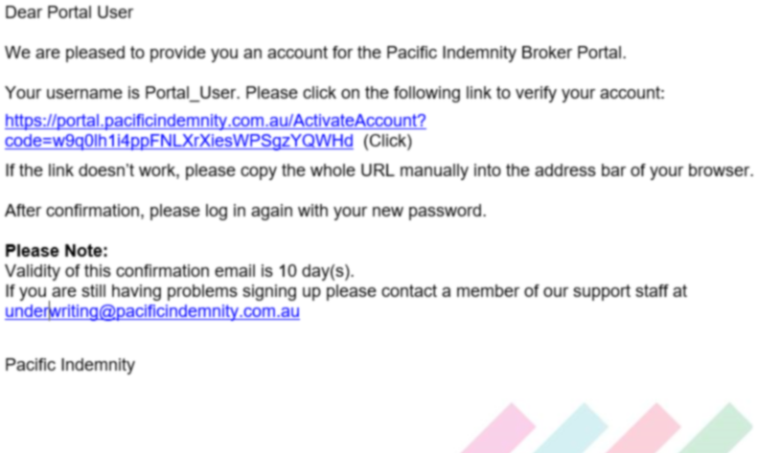
How to Access the Portal

- Activating Your Account
When first registered on the Broker Portal, you will receive an email requesting Activation of your account.

Click the hyperlink to Activate your Portal account and set your password.
The Activation email is valid for 10 days only. Please contact us if this has expired.
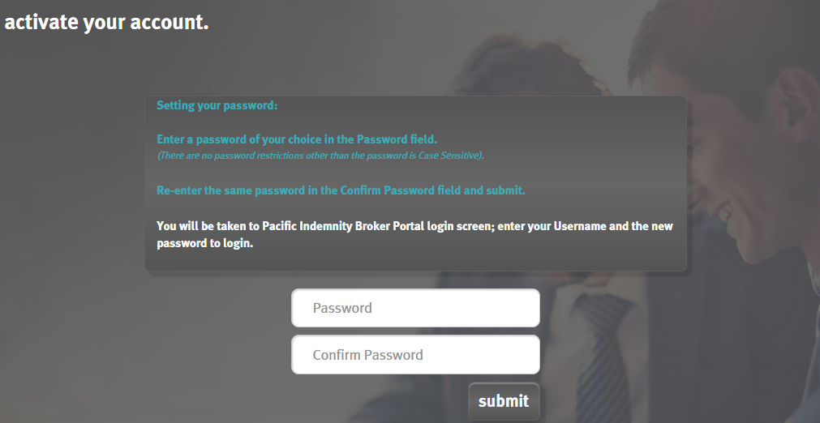
- Setting Your Password
When the ‘activate your account’ screen launches, enter the Password you wish to set for the Portal, then re-enter the Password to confirm. Click Submit.
Note: Passwords are case sensitive only

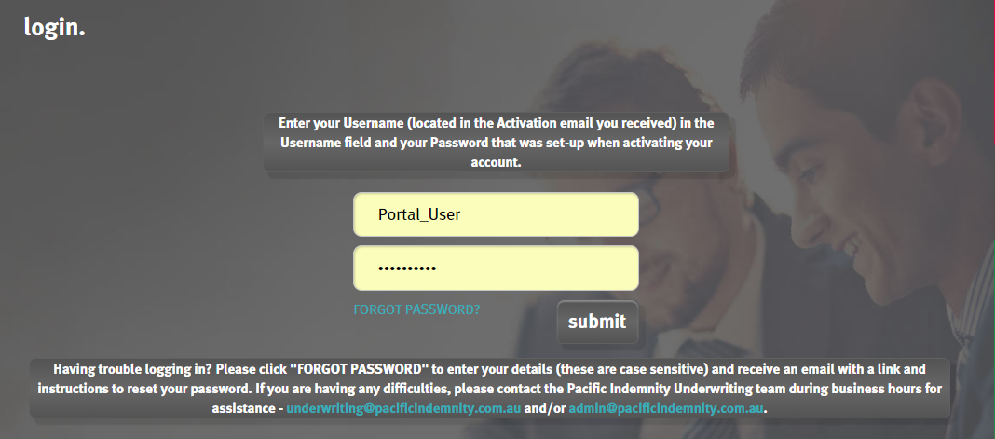
The screen refreshes to show the login screen

Enter log-in details
Upon confirmation of setting your password, the login screen will display.
Log in with your username (located in your Activation email) and new password.

- Accessing the Portal
The Login screen can be reached via https://portal.pacificindemnity.com.au, or www.pacificindemnity.com.au and click the ‘get a quote’ button

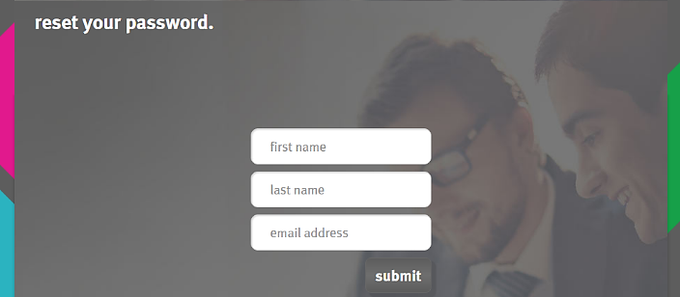
- Resetting Your Password
On the Login screen click FORGOT PASSWORD?, enter your first name, last name and email address and click submit button.
You will receive a confirmation message on screen and an email to complete the password reset.

The activation email with contain a link to reset your password. Please follow the Activating Your Account instructions above.

Search for existing quotes and renewals
Search Parameters include:
- Quote Number
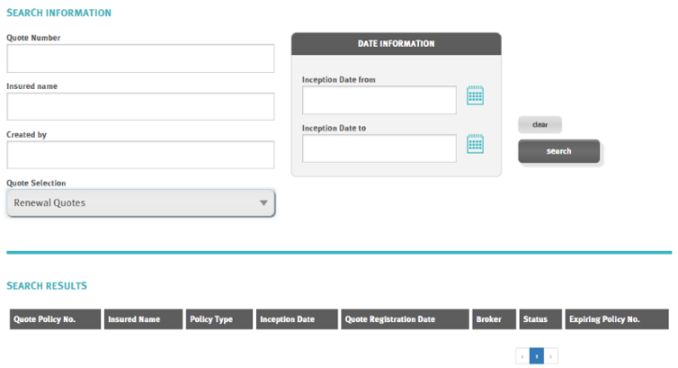
- Insured name
- Created by = the person who created the quote
- Inception Date - from and to
- Quote Selection = New Business and/or Renewal Quotes
OR leave blank to see all
Click

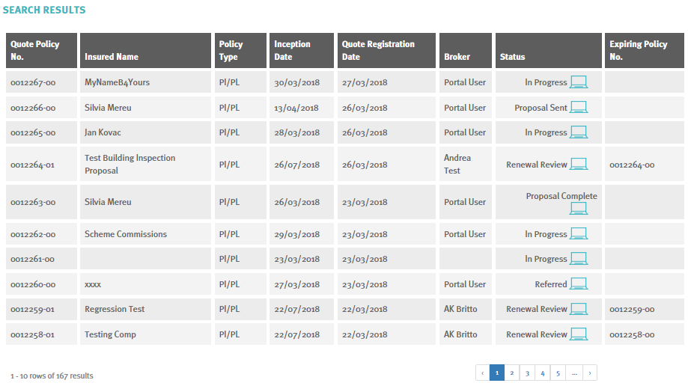
Example of Search Results
- Click icon to open the proposal page

Search for existing policy
Use this to search for Active (bound) Policies
Search Parameters include:
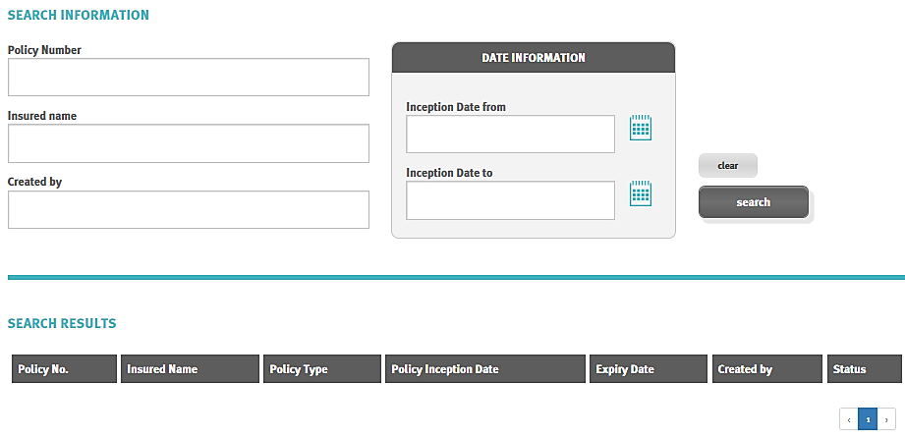
- Policy Number
- Insured name
- Created by = the person who created the quote
- Inception Date - from and to
OR leave blank to see all
Click

Would like further details?
Link to Welcome to the Pacific Indemnity Broker Portal – full instructional document

